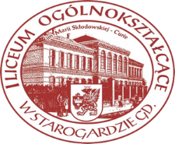
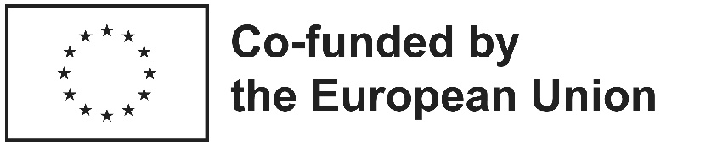

"The best waste is the waste that never existed,
and the best product is the one that has been given a second life."

This workshop was developed as a result of the Erasmus+ project:
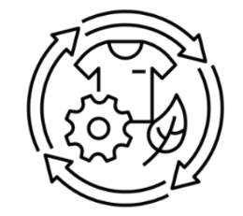
Erasmus+ KA121-SCH
Project No. 2024-1-PL01-KA121-SCH-000228869
and contributes to:
- Green Erasmus priorities,
- the European Green Deal,
- Education for Sustainable Development,
- Circular Economy principles,
- the development of environmental and civic competences.

LESSON PLAN / WORKSHOP SCENARIO
"Giving Waste a Second Life – From Used Cooking Oil to Eco-Friendly Products"
Circular Economy (CE) Workshop Developed within the Erasmus+ Programme

GENERAL INFORMATION
Title of the workshop:
Giving Waste a Second Life – From Used Cooking Oil to Eco-Friendly Products

Type of activity:
Environmental education workshop / Education for Sustainable Development / Citizenship education

Target group:
Secondary school students (aged 15–19)

Number of participants:
15–30 students

Duration:
2 lesson periods (90 minutes)

Venue:
Classroom / school workshop room / school common area

Authors:
Participants of the Erasmus+ KA121 project

CONNECTION WITH THE ERASMUS+ PROGRAMME
This workshop is one of the dissemination results of the Erasmus+ Accreditation project and contributes to the following objectives:
- promoting environmental education,
- supporting sustainable development,
- developing civic competences,
- fostering entrepreneurship skills,
- promoting interdisciplinary learning,
- disseminating the results of Erasmus+ mobilities.

MAIN OBJECTIVE
To develop students' environmental awareness through practical activities related to the principles of the Circular Economy (CE) and responsible consumption.

SPECIFIC OBJECTIVES
By the end of the workshop, students will:
Knowledge
- understand the concept of Circular Economy (CE),
- distinguish between linear and circular economic models,
- explain the 5R principles,
- understand the environmental consequences of excessive consumption,
- recognize the importance of recycling and upcycling.
Skills
- analyze how everyday choices affect the environment,
- propose solutions based on Circular Economy principles,
- transform waste materials into useful products,
- cooperate effectively in teams,
- present the outcomes of their work.
Attitudes
- develop environmental responsibility,
- strengthen sustainable habits,
- increase creativity and innovation,
- promote responsible consumption.

KEY COMPETENCES DEVELOPED
The workshop develops the following key competences:
✓ citizenship competences
✓ personal and social competences
✓ entrepreneurial competences
✓ scientific and technological competences
✓ digital competences
✓ cultural awareness and expression
✓ learning-to-learn competences

THE UN SUSTAINABLE DEVELOPMENT GOALS
The workshop contributes to:
SDG 4 – Quality Education
SDG 11 – Sustainable Cities and Communities
SDG 12 – Responsible Consumption and Production
SDG 13 – Climate Action

TEACHING METHODS
- brainstorming,
- guided discussion,
- project-based learning,
- experiential learning,
- collaborative learning,
- elements of design thinking,
- reflection and self-assessment.

FORMS OF WORK
- individual work,
- pair work,
- group work,
- workshop activities.

TEACHING MATERIALS
- multimedia presentation,
- computer and projector,
- glass jars,
- decorative paper,
- glue,
- scissors,
- paints,
- brushes,
- silicone soap moulds,
- used cooking oil,
- soap base,
- essential oils,
- labels,
- student worksheets,
- Circular Economy Product Passport.

LESSON PROCEDURE

STAGE I

Introduction to the Circular Economy

Time: 15 minutes
The teacher begins by asking the following question:
What happens to the things we throw away?

Students create a mind map with their ideas.
The teacher then presents two economic models:
Linear Economy:
Take → Make → Use → Dispose
Circular Economy:
Reduce → Reuse → Repair → Recycle

Students are introduced to the 5R principle:
- Refuse,
- Reduce,
- Reuse,
- Repair,
- Recycle.
A short discussion follows about sustainable lifestyles and environmental responsibility.

STAGE II

Educational Game: "A Second Life for Everyday Objects"

Time: 15 minutes
Students work in small groups.
Each group receives a set of everyday objects:
- a glass jar,
- a plastic bottle,
- cardboard,
- an aluminium can,
- newspapers,
- used cooking oil,
- paper packaging.
Task:
Students discuss and propose innovative ways to give these objects a second life.
Each group presents its ideas to the class.

STAGE III

Practical Workshop: Producing Eco-Friendly Soap from Used Cooking Oil

Time: 30 minutes
Students learn how waste cooking oil can be reused in environmentally friendly ways.
During the activity students:
- prepare the soap mixture,
- add natural ingredients and fragrances,
- use silicone moulds,
- design product labels.
While working, students discuss:
- the environmental impact of improper disposal of cooking oil,
- methods of reusing waste materials,
- the role of Circular Economy in sustainable development.

STAGE IV

Practical Workshop: Upcycling Glass Jars

Time: 20 minutes
Students transform used glass jars into new useful products.

Examples include:
- desk organizers,
- candle holders,
- plant pots,
- decorative containers,
- home accessories.
During the activity, students reflect on how they can reduce waste in everyday life.

STAGE V

Circular Economy Product Passport

Time: 5 minutes
Each student completes a Product Passport describing their item.
Category | Description
Product name
What was considered waste?
What new purpose does it serve?
Environmental benefits
Author

STAGE VI

Reflection and Evaluation

Time: 5 minutes
Students answer the following questions:
- What did I learn during the workshop?
- How can I apply Circular Economy principles in my daily life?
- What environmentally friendly actions can I take starting today?
- What was the most inspiring part of the workshop?

EXPECTED LEARNING OUTCOMES
After the workshop students:
Know:
✓ what Circular Economy means,
Can:
✓ apply the 5R principles,
✓ identify examples of recycling and upcycling,
✓ propose environmentally responsible solutions,
Demonstrate:
✓ environmental responsibility,
✓ sustainable consumption habits,
✓ creativity and innovation.

TANGIBLE RESULTS OF THE WORKSHOP
The workshop produces:
- eco-friendly soaps,
- upcycled products,
- photographic documentation,
- Circular Economy Product Passports,
- student presentations,
- increased environmental awareness.

ASSESSMENT AND EVALUATION
Evaluation is carried out through:
- observation of students' work,
- worksheet analysis,
- self-assessment,
- group discussion,
- assessment of final products.

